**Lab 5: Operational Amplifiers**

**Lab Report by: Talal Jawaid**

**Lab Session: Wednesday**

**Due Date of the Lab: 3/14/18 & 4/4/18**

**Date(s) of the lab: 4/11/18**

**Lab partner(s): Sergio Zavala and Amrit Singh**

1. **Introduction**

In this Lab we learn how to design a circuit which incorporates an operational amplifier or “op-amp” for short. We use the operational amplifier to amplify the signal being outputted from a given circuit. The op-amp has it’s own voltage sources, which in our case were both positive and negative nine volts.

1. **Purpose**

The purpose of this lab is the provide students with an introduction to practical operational amplifiers. In addition, we have the opportunity to become familiar with the oscilloscope, power supply, function generator, and multimeter. Students are to observe and learn how operational amplifiers work, in addition to how and when they can be implemented.

1. **Procedure:**

For this lab, we used the single input inverting configuration, the simple strain gauge circuit, and the weighted summer amplifier circuit. Since the simple strain gauge circuit included a delta R which was actually three different resistors that were to be swapped out and measurements made for each one, we actually created 5 different circuits and took measurements and calculated theoretical gain for each one. Before we started, we first obtained 1k ohm resistors and the LM741 op-amp from the professor, as well as the resistors that were required for the remaining parts of the lab. We also had to replace the 4.3k ohm resistor with a 4.2k ohm resistor as a 4.3k ohm resistor could not be obtained. We believe this didn’t make a significant difference in our results as our 4.2k ohms resistor actually had a measured resistance of 4.296k ohms. Afterwards, we checked the wiring carefully because applying the voltage with the polarity reversed on the op-amp would result in us “frying” the op-amp. Using the pin sheet, we made sure that the voltage was of the correct polarity. After hooking up the circuit, we connected the oscilloscope’s function generator and the power supply to supply our circuit as well as our op-amp with power. For part one, we applied 3 volts approximately to the circuit and 9 volts to the op-amp. On the oscilloscope we adjusted the frequency to 500Hz and set the amplitude to 3.00 Vp-p. For part two, we applied the same voltage, but increased the voltage from the oscilloscope until distortion was observed. We then reduced the voltage and applied a DC voltage offset and then increased that until distortion was observed. For part three, we used the same voltages as part one but we switched out the delta R resistors, which made it actually three different circuits. For part four, we applied 2 Vp-p 500Hz sinusoidal signal for input #1 and 2 Vdc for input #2. For all of our circuits, the voltages powering the op-amp were the same at +- 9V. We then used the oscilloscope and DMM to measure the voltages in and out of each circuit and used the values measured to compare against our theoretical values.

1. **Data**

**Part 1:**

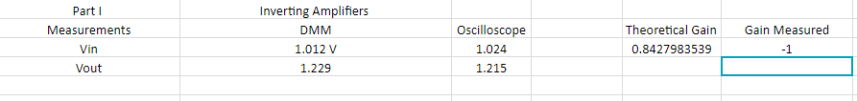

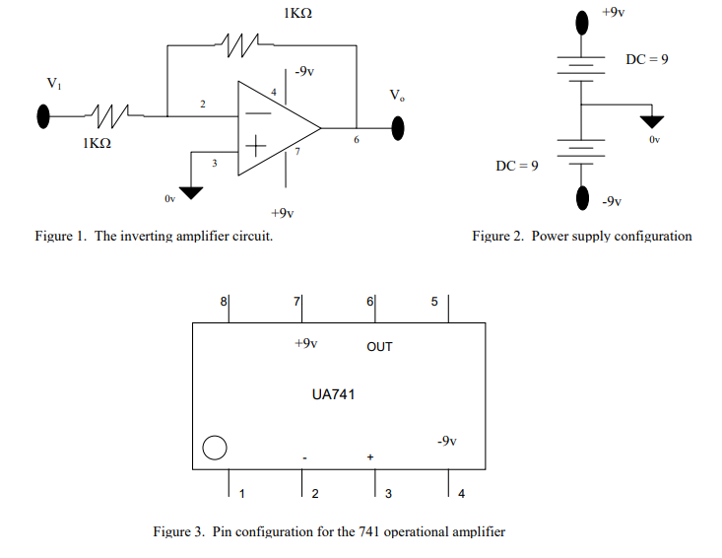

**Part 2:**

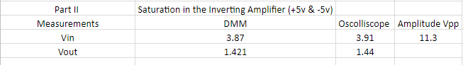

**(Same circuit as part 1)**

**Part 3:**

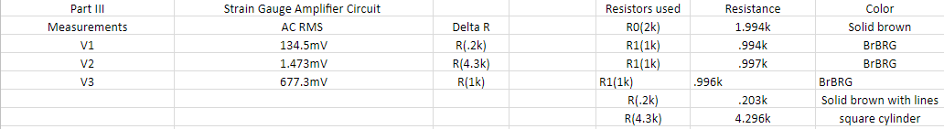

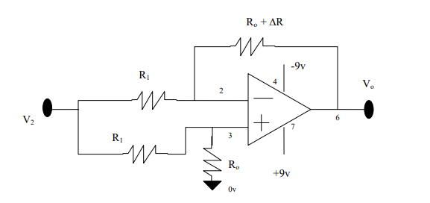

**Part 4:**

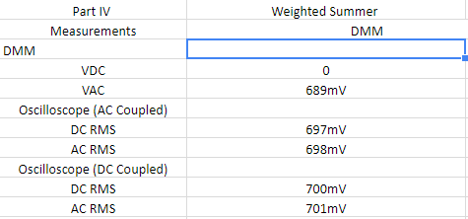

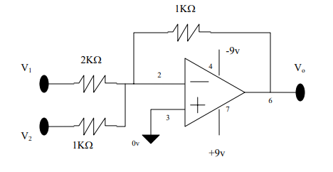

1. **Conclusion:**

In conclusion, we were able to accurately calculate for the theoretical gain, which ended up being very close to our measured gain. We defined our measured gain as

-1 due to the fact that the phase shift was supposed to be and observed to be 180 degrees, which should make the voltage be the same but inverted. We believe that any discrepancy between our theoretical and our measured gain is not likely to be due to errors in calculation, as the calculation was very simple. It is likely to be an error with our measurements or perhaps an issue with our oscilloscope or DMM.